Notice on Updating the Corporate Online Banking
Login Method
Dear Valued Customer:
To ensure the security of customer accounts, China Construction Bank will update the corporate online banking login method starting at 00:00 on June 22, 2024. Please download and install our "E-Safety" online Banking Components in advance and log in using a browser that supports our corporate online banking. The login URL is updated to https://intl.ccb.com/NCCB/V6/STYA/EN/login_vn.jsp.
Questions You May Concern：
How to Download the "E-Safety" Internet Banking Components?
To obtain the latest version of the "E-Safety" Internet Banking Components, please follow these steps:
- Open the link（https://www.ccb.com/chn/home/ebank/company/wsyx/xzzq/index.shtml）
- Click on “新版 E路护航 ” and the download will begin automatically.
Alternatively, if you encounter the following error prompt when logging into corporate Internet banking, you can click the blue "download" text to download the "E-Safety" Internet Banking Components.
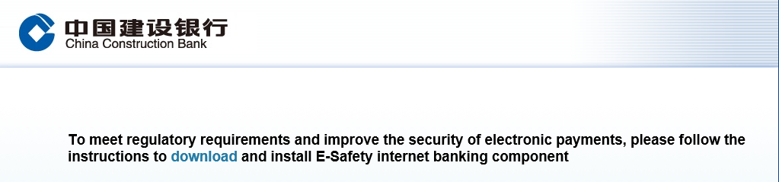

What Browsers are Supported to Log into Corporate Internet Banking After the Upgrade?
The following browsers are supported:
- Microsoft Internet Explorer (IE 10 or later versions)
- Microsoft Edge (With IE compatible mode on)
- 360 Explorer (With IE compatible mode on)
- Sogou Explorer (With IE compatible mode on)
- Other web browsers compatible with the IE kernel

After Installation, Login Page Still Prompts to Download “E-Safety”？
If you encounter this prompt appear at the top or bottom of the browser after installing the "E-Safety" Internet Banking Components, please click "Allow" and refresh the page.
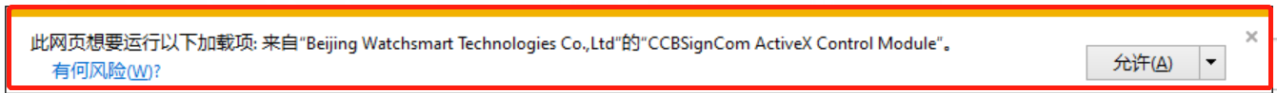

Error Prompt Persist When Logging in with a Browser That Supports Corporate Internet Banking
- Microsoft Edge:
  - In the address bar, type “edge://settings/defaultbrowser” and click enter;
  - Find the “Allow sites to be reloaded in Internet Explorer” option and slide the toggle to ON;
  - Restart Microsoft Edge and visit Corporate Internet Banking;
  - Click the three dots in the upper right corner of the browser window;
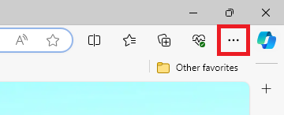
  - Select “Reload in the Internet Explorer Mode”.

- 360 Explorer, Sogou Explorer or other web browsers compatible with the IE kernel:
  - Please refer to the screenshots below, Click on the lightning icon located on the right side of address bar, then select "IE Compatibility Mode" or “兼容模式”.
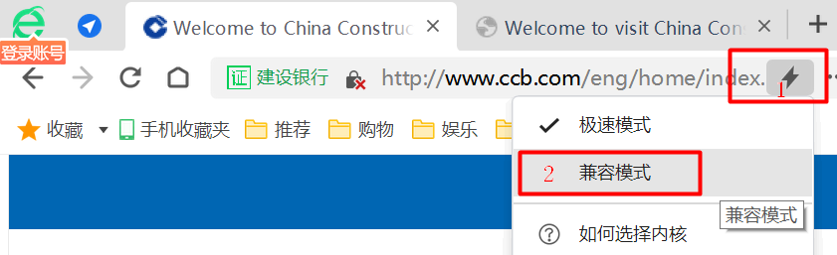
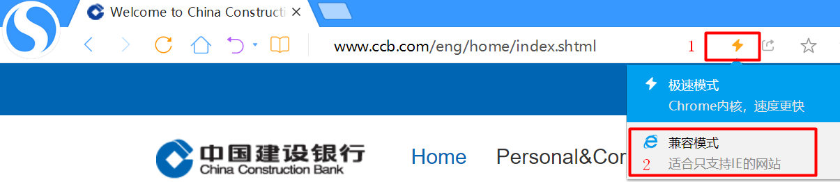

For any questions, please call our customer service hotline at: +84 2838295533.

